

Last Reviewed & Updated: | July 2025 | Due for Review: | July 2026

Young Carers Policy

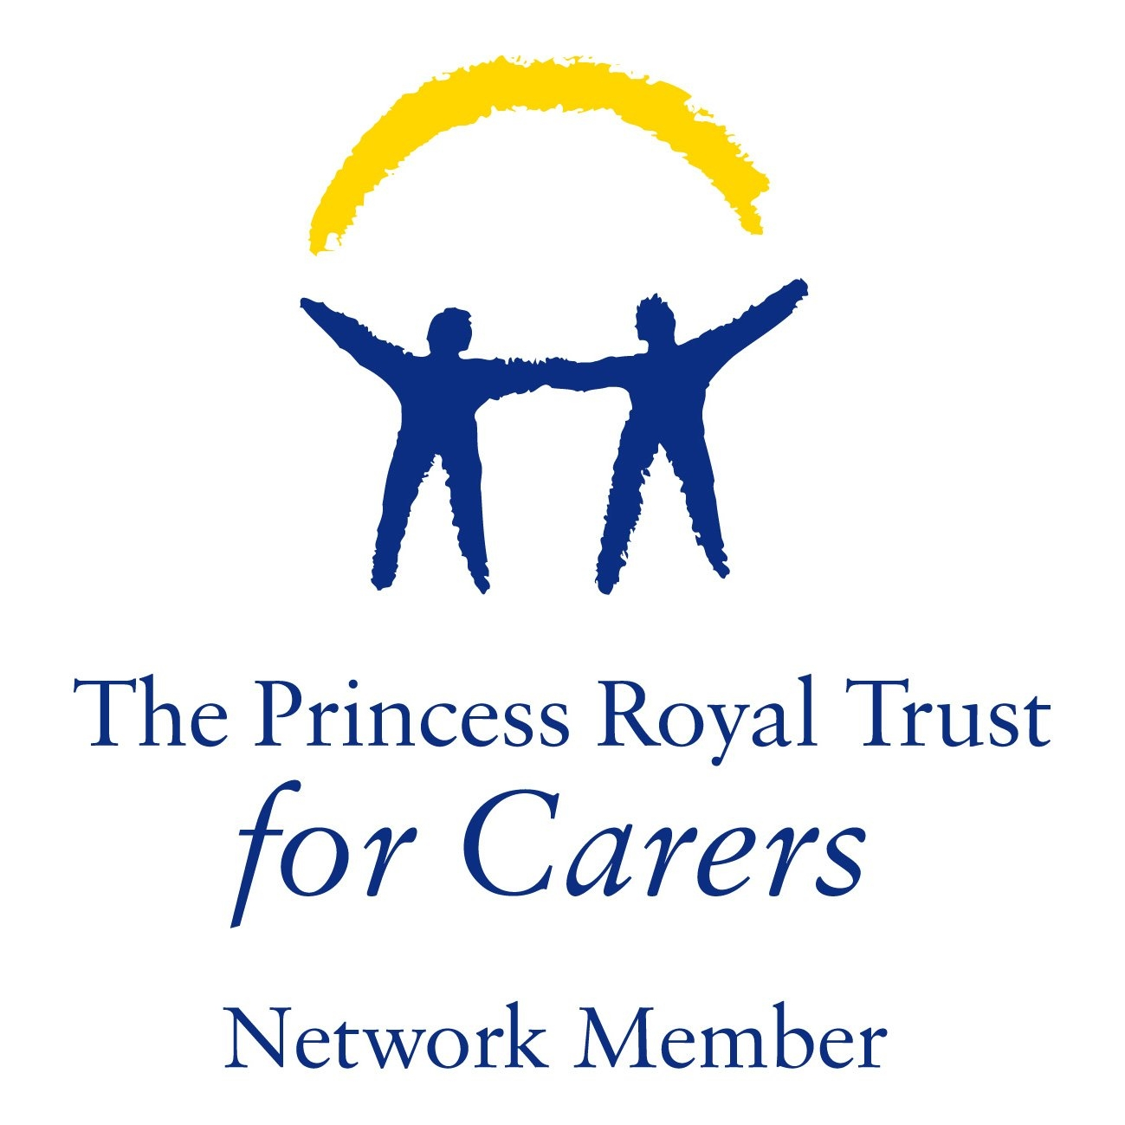

Young Carers Policy

Our duty –

The Pendlebury Centre PRU is committed to enabling young carers to access education and support. This policy aims to ensure young carers at this school are identified and offered appropriate support to access the education and other services to which they are entitled. In addition to this we have our Young Carer Charter signed by the Headteacher & Chair of governors.
The Children and Families Act 2014 and the Care Act 2014, both significantly strengthened the rights for young carers. They aim to assess and support children and young people from taking on excessive or inappropriate care. Our barriers and solutions resource explains how to implement the new duties to young carers and their families.
They also recognised the need to improve young carers’ transition to adulthood. Following the launch of the Carers Action Plan, we were commissioned by the Department of Health and Social Care to identify and disseminate effective practices to support, to enable young adult carers to make positive transitions between the ages of 16 and 24. You can read more about this in our shaping our Future report.

Definition -

Young carers are children and young people who provide care to another family member.
The level of care they provide would usually be undertaken by an adult and as a result of this they take on a level of responsibility that is inappropriate to their age and development. This is likely to have a significant impact on their childhood experiences.

The person they look after will have one or more of the following:

- Physical disability
- Sensory disability
- Learning disability
- Mental health problem
- Chronic illness
- Substance misuse problem

Caring Tasks

A young carer will take on additional responsibilities to those appropriate to their age and development. A young carer might be providing the main care or share responsibilities with another family member. The caring tasks that a young carer has to deal with can range from:

Nursing care – giving medication, injections, changing dressings, assisting with mobility etc.

Personal intimate care – washing, dressing, feeding and helping with toilet requirements.

Emotional care – being compliant, monitoring the emotional state of the person cared for, listening, being a shoulder to cry on, supporting a parent through depression and trying to cheer them up. In cases where a young carer is supporting an adult with drug/alcohol misuse problem, they will often take a leading role in trying to keep that person safe.

Domestic care – doing a substantial amount of housework, cooking, shopping, cleaning, laundry etc.

Financial care – running the household, bill paying, benefit collection etc.

Child care – taking responsibility for younger siblings in addition to their other caring responsibilities.
Communication & Interpreting – communicating on behalf of the adult or family with agencies/services and interpreting for a language or sensory impairment.

If you feel that your child may be a young carer, please contact Mrs Maxey or Miss Skehan and we will strive to support your child and the family as much or as little as required, we can signpost and refer to Stockport Young Carers which will enable assessments to be carried out and consequently offer further support including but not limited to; Take a break – respite, benefit help and financial advice, wellbeing support, help picking up prescriptions and necessity’s whilst your child is in school.

Possible effect on education

The Pendlebury Centre PRU acknowledges that there are likely to be young carers among its pupils, and that being a young carer can have an adverse effect on a young person’s access to education and attainment.

Because of their responsibilities at home, a young carer might:

- Have erratic or poor school attendance
- Arrive late at school
- Decline in academic achievement
- Not complete homework
- Not attend out of school activities or school trips
- Lack motivation
- Have back problems, aches and pains patterns of being generally unwell
- Appear withdrawn, isolated from peers, have difficulties socialising
- Show, anxiety, depression, anger, self-harming behaviour
- Have poor concentration (due to worrying about the person who is cared for)
- Have poor home/ school relationship
- Have parents who do not attend parents evening or lack of overall contact with school
- Have false signs of maturity, assuming an adult role in social situations or have difficulty enjoying childhood activities.

Support Offered

School acknowledges that young carers may need extra support to ensure they have equal access to education and opportunities offered through the life of a school. Through this policy, school is giving the message that young carers’ education and school experience is important.

Additionally, we adopted the No Closed Door for Young Carers Memorandum within the Centre. No Wrong Doors for Young Carers' is important because it makes it easier for young carers to seek help when they need it. It ensures that no matter who they speak to or where they go, they will be supported and guided in the right direction. This removes any barriers that could stop young carers from getting the help they deserve.

The designated school lead for young carers is Jane Maxey and the Operational lead is Sinead Skehan, designated staff will liaise with relevant colleagues, Stockport Young Carers and other relevant agencies with the consent of the young carer. All pupils will be made aware of the designated link.

The Pendlebury Centre PRU will ensure that appropriate information is shared with school staff in order that there is an awareness of the young carer’s situation.

The Pendlebury Centre PRU will provide young carers with opportunities to speak to someone in private, and will not discuss their situation in front of their peers.

The Pendlebury Centre PRU appreciates that young carers will not discuss their family situation unless they feel comfortable. The young person’s caring role will be acknowledged and respected.

The Pendlebury Centre PRU will treat young carers in a sensitive and child-centred way, upholding confidentiality.

The Pendlebury Centre PRU will ensure young carers can access all available support services in school and other appropriate services/agencies.

The Pendlebury Centre PRU will follow safeguarding procedures regarding any young carer at risk of significant harm due to inappropriate levels of caring.

The Pendlebury Centre PRU will promote discussion and learning in all areas of the curriculum to facilitate fuller understanding, acceptance of and respect for, the issues surrounding illness, disability and caring.

The Pendlebury Centre PRU recognises that flexibility may be needed when responding to the needs of young carers. Available provision includes (but is not limited to):

- Access to a telephone during breaks and lunchtime, to phone home
- Negotiable deadlines for homework/coursework (when needed)
- Access to homework clubs (where these are available)
- Lunchtime detentions rather than after school detentions (where possible)
- Arrangements for schoolwork to be sent home (where there is a genuine crisis). Any approved absence for a young carer will be time limited (DfES 2006)
- Access for parents with impaired mobility
- Alternative communication options for parents who are sensory impaired or housebound
- Advice to parents if there are difficulties in transporting a young carer to school

For further information please contact Young Carers in the first instance on – 0161 442 0442 info@signpostforcarers.org

For further information & online support –

https://www.nhs.uk/conditions/social-care-and-support-guide/support-and-benefits-for-carers/being-a-young-carer-your-rights/

https://childlawadvice.org.uk/information-pages/young-carers/

https://carers.org/downloads/no-wrong-doors-for-young-carers---mou-(final-version).pdf

